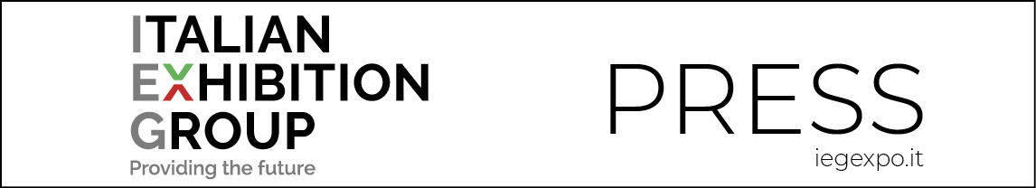

press release
(English translation)

ITALIAN EXHIBITION GROUP:
TOMMASO CANCELLARA WILL BE THE NEW MANAGING DIRECTOR OF IEG USA AND VICE PRESIDENT OF FB INTERNATIONAL

The trade show and congress group
announces the appointment of Cancellara as head of the IEG company
responsible for trade show business development in the United States.

Rimini, 8th February 2022 – Italian Exhibition Group announces the name of the new managing director of IEG USA, a company 100% owned by the trade show and congress group and an operational tool for new development and business initiatives in North America. The American trade show market was worth 15.58 billion dollars prior to the pandemic.

The new MD is Tommaso Cancellara, born in 1980, with a degree in Institutional and Business Economics obtained in Lugano. Cancellara made his professional debut with the Ferrari-Maserati Group. Since 2010 he has held positions of increasing responsibility within Technogym, becoming APAC Marketing Manager for the Shanghai office until 2014. He then became general manager of Assocalzaturifici Italiani, the National Association of Italian Footwear Manufacturers, which groups together more than five hundred footwear producers, and has served as managing director at Micam, the most important event in the footwear sector with more than 2,000 exhibitors from 50 countries.

FB USA also owns FB International, the outfitting company with two operative branches, one in Oakland, New Jersey, covering the entire East Coast from Canada to Miami, and the other in Las Vegas, Nevada, covering the entire West Coast of the United States.

Tommaso Cancellara will take up his new duties as of next April and will have the dual task of consolidating, together with founder Fabrizio Bartolozzi, the outfitting sector overseen by FB International and developing the group's exhibition activities in the North American market.

FOCUS ON ITALIAN EXHIBITION GROUP
Italian Exhibition Group S.p.A., a joint stock company listed on Euronext Milan, a regulated market organised and managed by Borsa Italiana S.p.A., has, with its facilities in Rimini and Vicenza, achieved national leadership over the years in the organisation of trade shows and conferences. The development of activities abroad - also through joint-ventures with global or local organisers, in the United States, United Arab Emirates, China, Mexico and India, for example - now sees the company positioned among the top European operators in the sector.

PRESS CONTACT: media@iegexpo.it
This press release contains forecast elements and estimates that reflect the management’s current opinions (“forward-looking statements”), particularly regarding future management performance, realization of investments, cash flow trends and the evolution of the financial structure. For their very nature, forward-looking statements have a component of risk and uncertainty, as they depend on the occurrence of future events. The effective results may differ (even significantly) from those announced, due to numerous factors, including, only by way of example: food service market and tourist flow trends in Italy, gold and jewellery market trends, green economy market trends; the evolution of raw material prices; general macroeconomic conditions; geopolitical factors and evolutions in the legislative framework. Moreover, the information contained in this release, does not claim to be complete, and has not been verified by independent third parties. Forecasts, estimates and objectives contained herein are based on the information available to the Company as at the date of this release.

